**Problem Statement 8: Brownie Points Task : TinkerCad**

Make an automation circuit-It becomes a tedious task to perform a set number of use cases in the office each morning so we want you create a circuit that can do the following

* Open Up the motorized shades of the office
* Trigger the lights on with the help of a relay one by one (total lights 5)
* Use a force sensor underneath the entrance mat to check if someone enters then it has to keep the sanitizer motor on for 5 seconds

## Solution →

Step 1 – Circuit Diagram

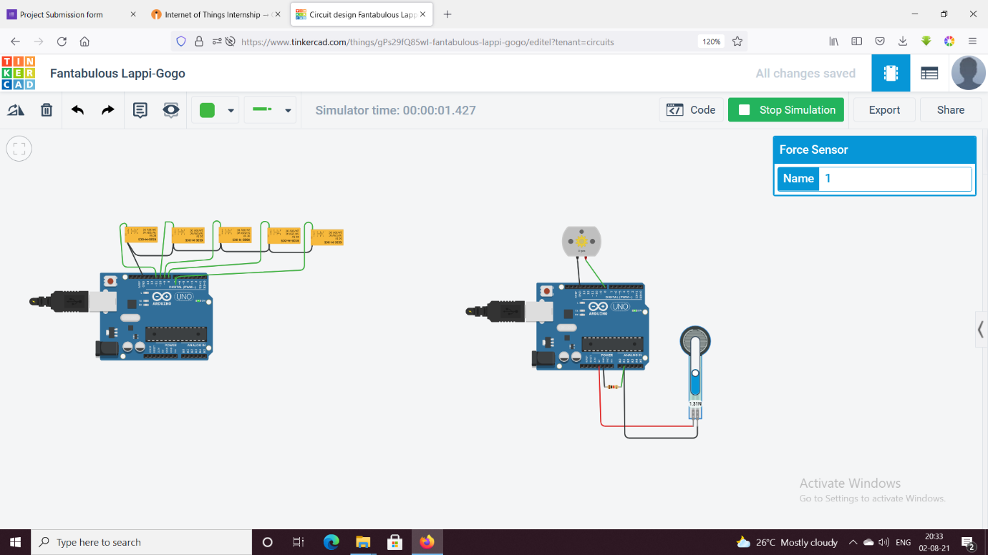

Step 2 – Code:

// C++ code

//

int motor_pin = 8;

int readValue = 0;

int Value = 0;

void setup()

{

pinMode(motor_pin,OUTPUT);

}

void loop()

{

readValue = analogRead(A1);

Value = map(readValue,0,1024,0,255);

analogWrite(motor_pin,Value);

}